Ideation Phase
Define the Problem Statements

Date | 01 Nov 2025
Team ID | NM2025TMID01600
Project Name | Laptop Request Catalog Item
Maximum Marks | 2 Marks

Customer Problem Statement Template:
Employees often need new laptops for official work, but the current manual request and approval process causes delays, confusion, and lack of tracking. Requests made through emails or verbal communication often go unnoticed, leading to slow fulfillment, duplicate requests, and missing approval records.IT administrators and managers also face issues verifying eligibility, available stock, and approval authority. This results in inefficient workflows, resource mismanagement, and poor visibility into the asset allocation process.A streamlined Laptop Request Catalog Item in ServiceNow can automate and simplify the process by allowing users to raise requests digitally, route them for approval, and track the status in real time. This solution improves transparency, accountability, and overall efficiency.

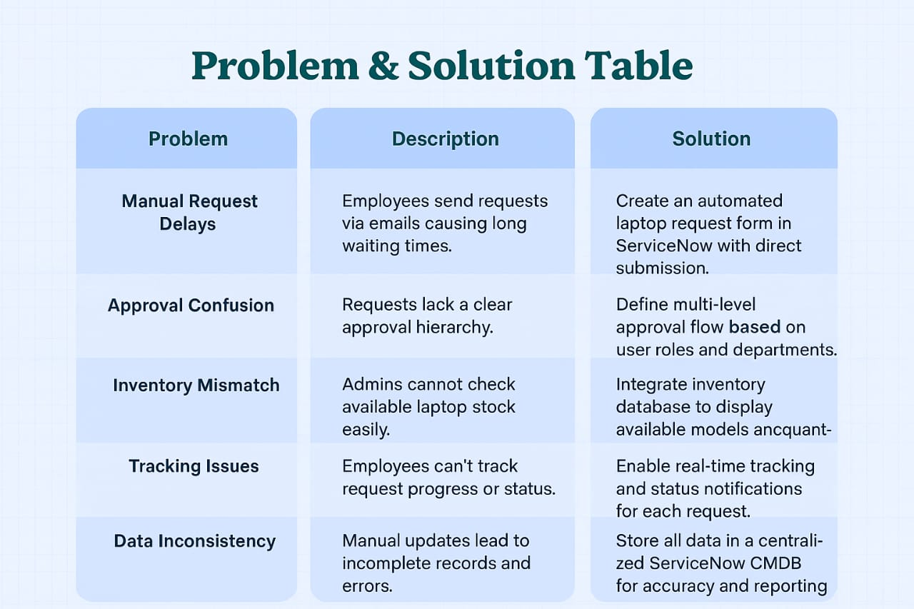

Example:

Problem  Statement (PS) | I am  (Customer) | I’m trying to | But | Because | Which makes me feel
PS-1 | An Employee | Request a new laptop | The process is slow | Approvals are manual and take too long | Frustrated and unproductive
PS-2 | An IT Admin | Manage and approve laptop requests | Requests lack proper tracking | No unified system to view status or stock | Confused and overwhelmed

Problem Statement PS 1:
As an employee, I want to request a new laptop through a simple digital form so that my manager can approve it quickly and I can track its status in real time. Currently, the process is manual and requires sending multiple follow-up emails, causing unnecessary delays.
This impacts my productivity, as I cannot start my assigned work without the necessary device.
Problem Statement PS 2:
As an IT Administrator, I want to view and approve all pending laptop requests in one place, so that I can process and allocate laptops efficiently. Currently, approvals are scattered across emails, and there’s no central record to check inventory or request history.
This leads to miscommunication, unrecorded allocations, and extra workload.

